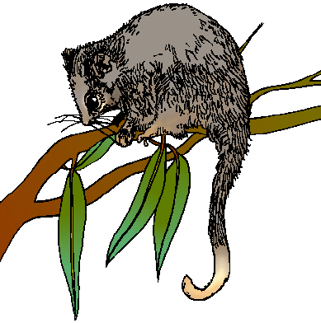

### Rosanna Cub Scouts

**Activity: Possum Prowl**

**When:** Tues7th June, 2022

**Start Time:** Arrive **6:45pm** – need to make arrangements and tour starts at 7 sharp

**Finish Time:** 8.30pm

**Cost: $15** (each for ALL attending)



**Where:** La Trobe University

Nangak Tamboree Wildlife Sanctuary

**Meet at:**

Wildlife Sanctuary Office – enter from

LaTrobe Ave – between Main Dve

and Ring Rd: <https://goo.gl/maps/n9o1GvyGFv32>

**Don’t be late…**

- call 0411 121 495 if any problems.

**What to wear:**

Cub Uniform (or white scarf)

Solid Footwear for walking

Dress for warmth and bring a coat if necessary, waterproof gear if likely to rain

No torch – Adults only (*don’t want to affect night vision*)

**What we will see:**

Good Question! It depends on two things.

1. How noisy you are – *maybe* kangaroos, bats, frogs, possums, owls and more

2. The Weather – if it’s raining, it will MOST likely STILL be on, so wear waterproof gear and have fun!

A ranger will take us on a guided tour, so we’ll see as much as we can.

**WE NEED TO KNOW NUMBERS ASAP… PLEASE ADVISE AKELA HOW MANY YOU WILL HAVE ATTENDING ($15 each) ON: akela@rosannacubs.org**

**NOTE: we have a *cap of 30 people*….With regards to parents/siblings… first in, best dressed after Cubs/Leaders are included (but if *they* take too long to respond they may miss out), so don’t delay – please let us know numbers who’d like to go now, I’ll advise who gets in and on the night we’ll go up to our limit of 30, having selected in order of first emailed responses.**